# SPECIAL OLYMPICS SIGNATURE FORM

The Special Olympics Terms and Conditions are basic rules for participation in Special Olympics. The full wording of the Terms and Conditions can be found here:

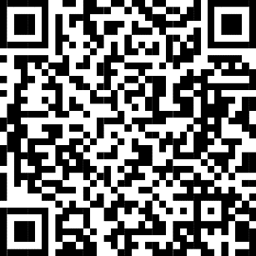

<https://www.specialolympics.ca/british-columbia/terms-and-conditions-participation>

Athletes/volunteers must agree to the Terms and Conditions to participate in Special Olympics. By signing below you agree to the Special Olympics Terms and Conditions on behalf of yourself or your child/ward.

## Part 1: CRIMINAL RECORD

Has the person who is being registered or enrolled ever been charged with or convicted of any criminal offence?

Circle one response:

 **No ** **Yes**

## Part 2: MEDIA RELEASE OPT-IN/OPT-OUT

I allow Special Olympics to use my/their picture, words, or voice in promotional media. Circle one response:

**Yes No**

**Part 3: SIGNATURE**

**I agree to the Special Olympics Terms and Conditions and attest that my answers on the media release opt-in/opt-out and criminal record are true.**

**If you are signing for yourself, please complete this section:**

**__________________________________ ________________________________**

## First Name Last Name

**___________________________________ _________________________________**

## Signature Date

**OR**

## If you are signing on behalf of your child or ward, please complete this section:

**__________________________________ ________________________________**

## Child/Ward First Name Child/Ward Last Name

**__________________________________ ________________________________**

## First Name Last Name

**___________________________________ _________________________________**

**Signature Date**